Nama : Syaira Yuniar
NPM : 11123280
Kelas : 3KA20
[Sesi 2] ACT 2 Workshop Javascript
Program 1
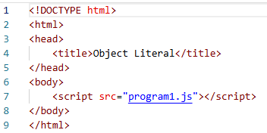
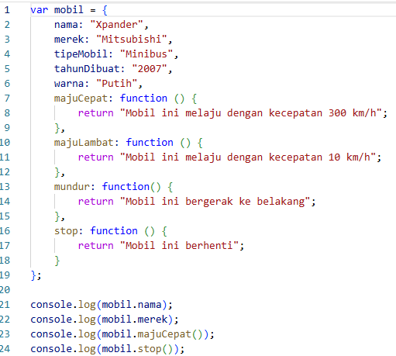
Output Program 1
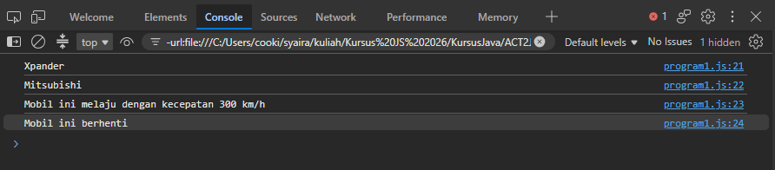

Program 2
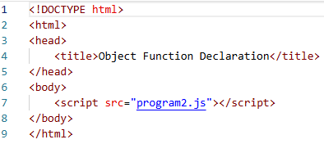
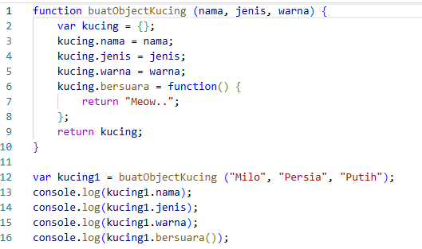

Output Program 2
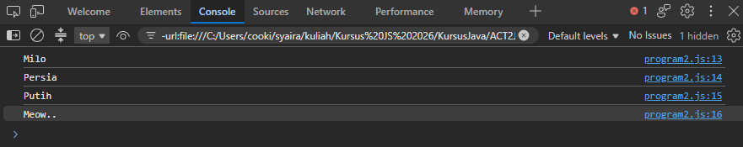

Program 3
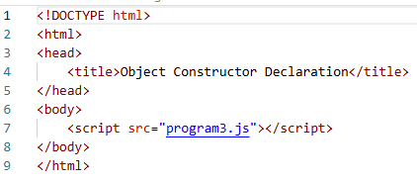
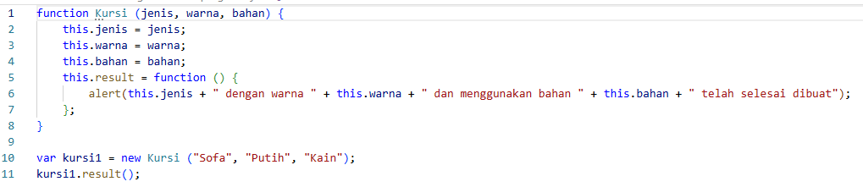

Output Program 3
